TEAM 20

**Remote Health Monitoring System**

Project Report

* **Group member details:**

PAMIDI MOHAMMAD ASHRAF: S20210020303

SANDEEP NIDAMANURI: S20210020300

PRAVEEN KUMAR: S20210020313

J MOHIT NAGA VARDHA GANESH: S20210020283

**Final Block Diagram:**

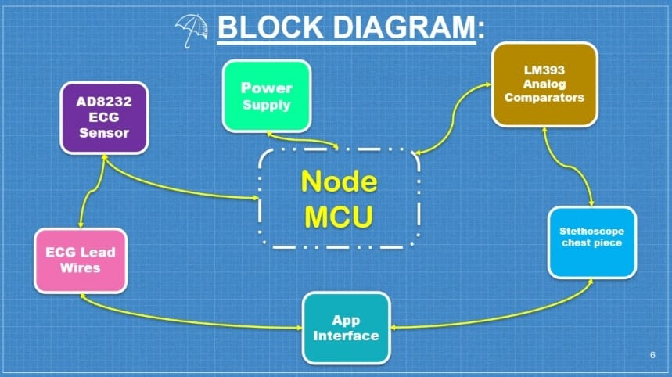

**COMPONENTS:**

HARDWARE

LM393 Analog Comparators

Breadboard

Stethoscope chest piece

Medical grade tube

Jumper Wires

Node MCU

AD8232 ECG Sensor

ECG Lead Wires

SOFTWARE

* Arduino IDE
* MIT App Interface/Web framework interface
* Firebase

**Outputs:**

App Outcomes:

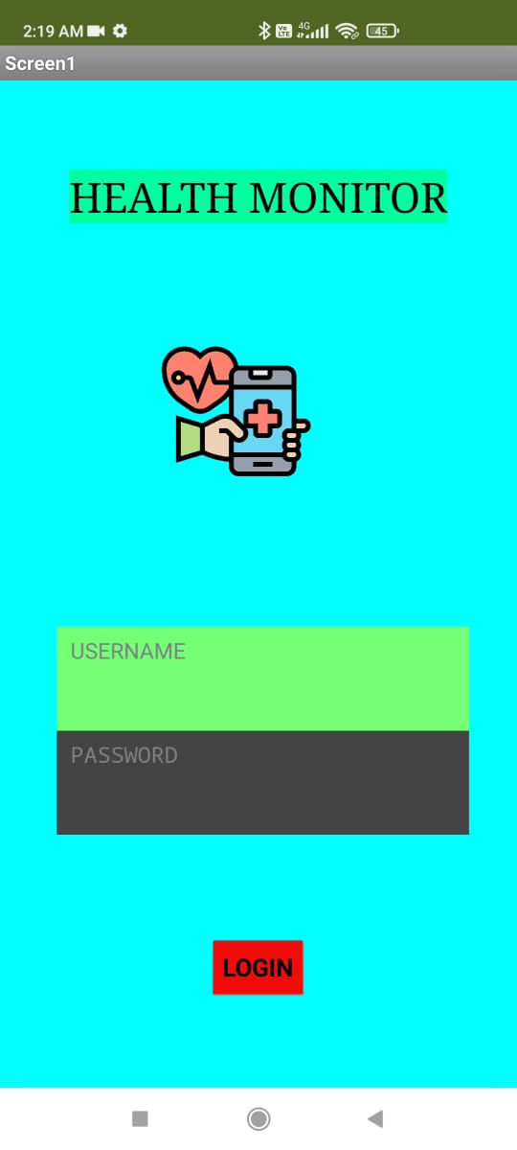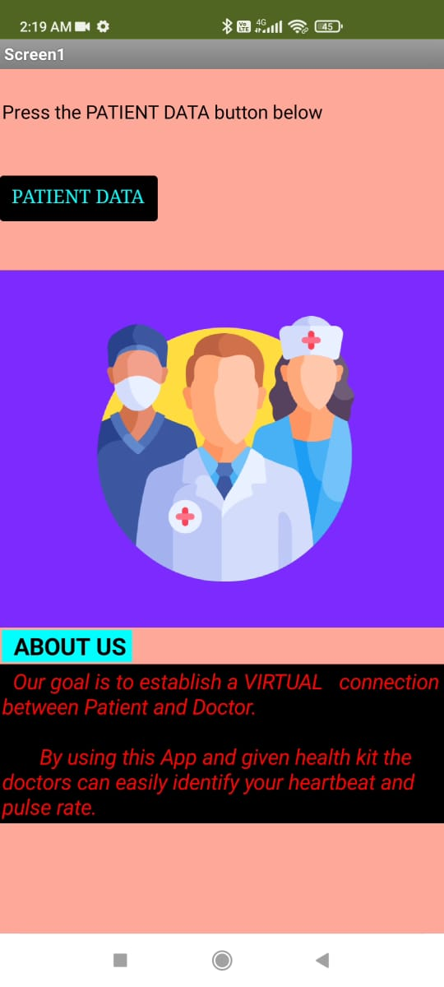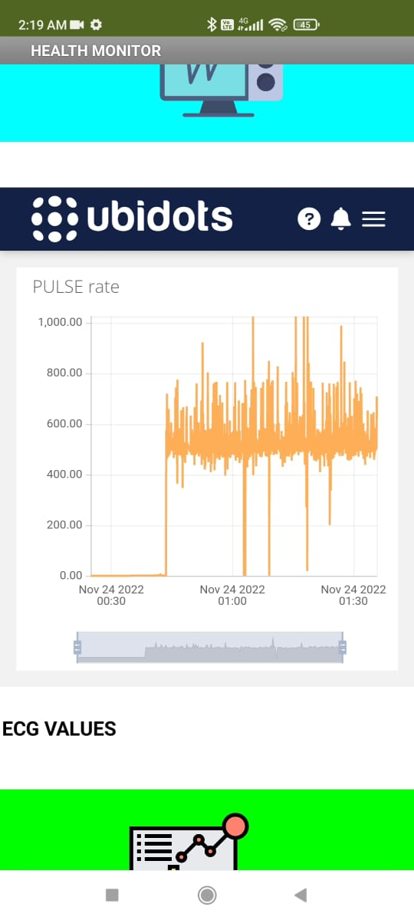

Login Page Introduction Page ECG plotting

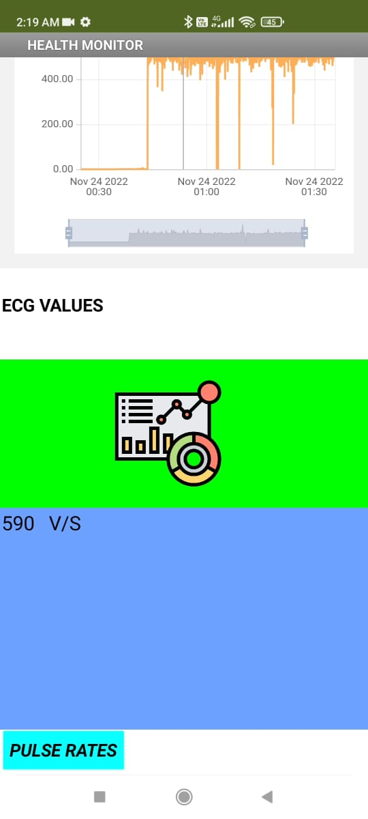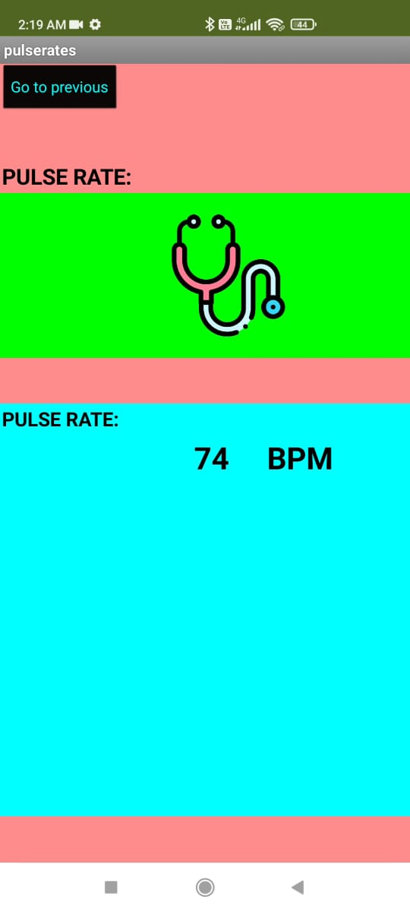

Pulse Rate ECG values

ECG of candidate 1:

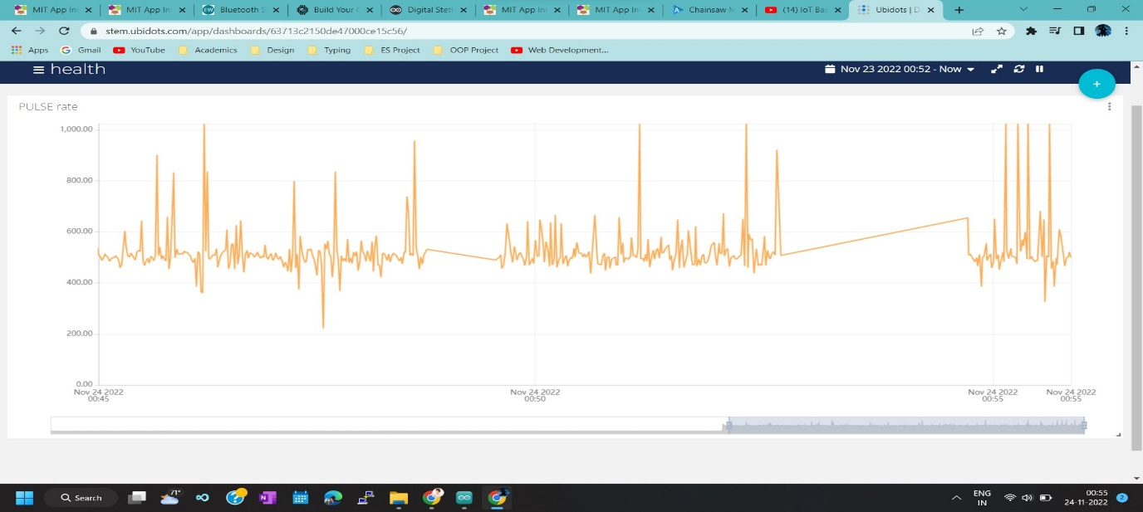

ECG of candidate 2: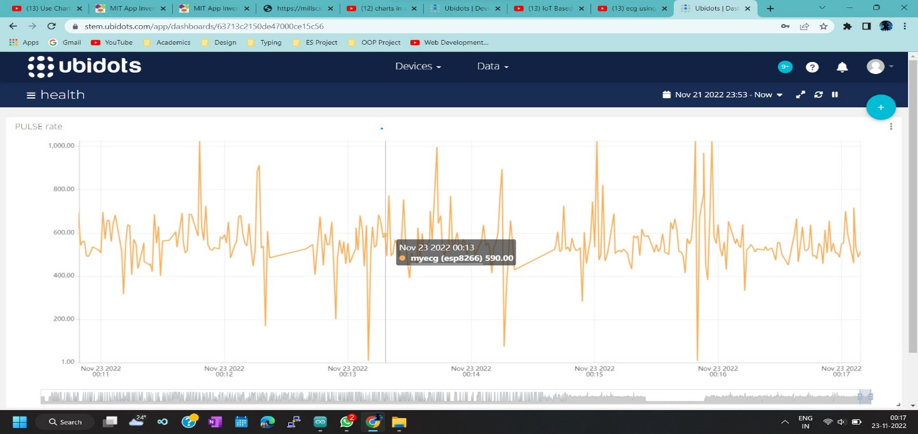

Pulse rate of the candidate:

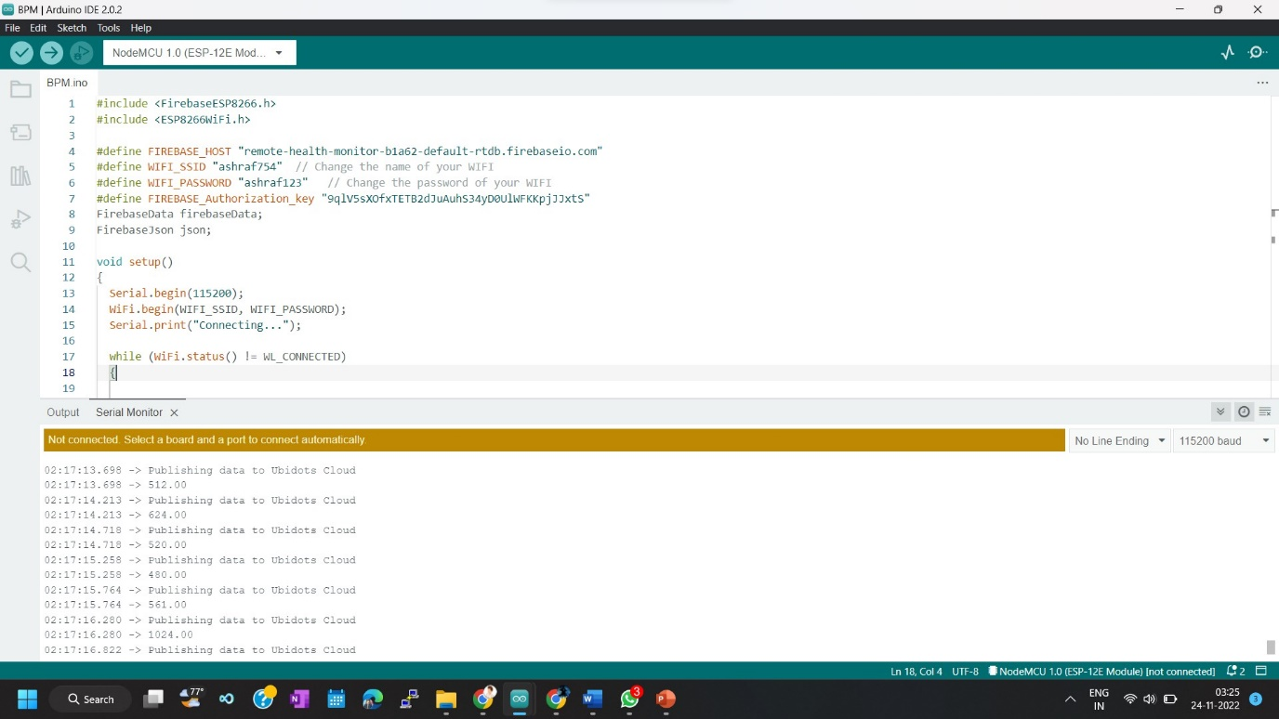

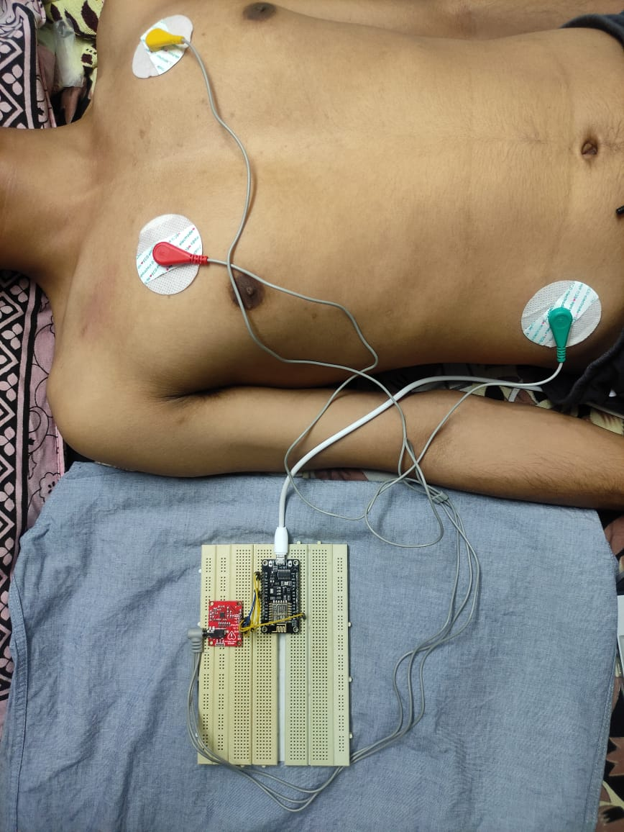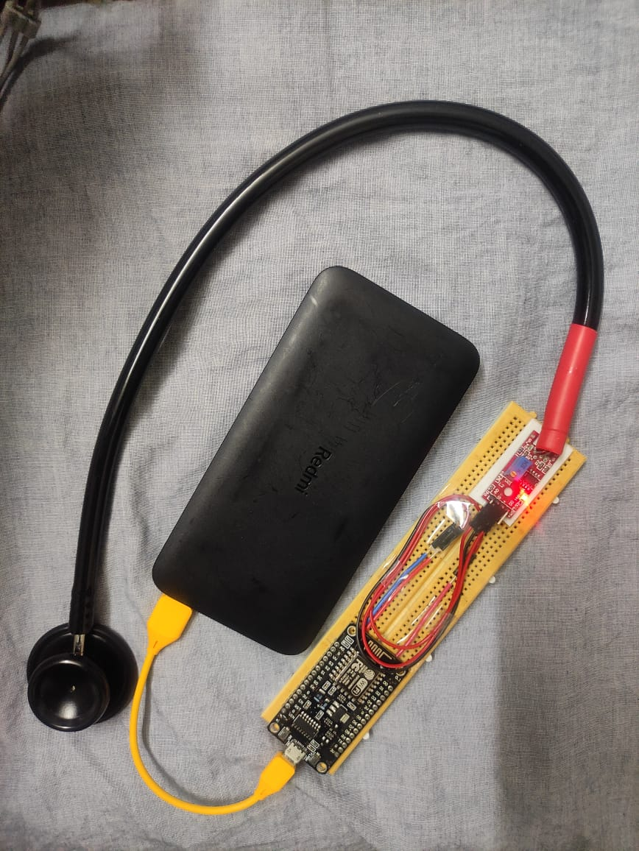Project Models:

Remote ECG Remote Stethoscope

**Challenges faced:**

**Codes:**